**Home assignment 1**

SF1811 Optimization

Yue Jiao

911024-7799

**Problem formulation**

In this assignment, the following optimizing problem of network flow is analyzed and solved under several different conditions. We have a network flow problem with two flows as presented in the figure below. The dashed segments represent the red flow and the solid segments represent the blue flow. The problem is to minimize the maximum of the sums of the flows between these nodes.

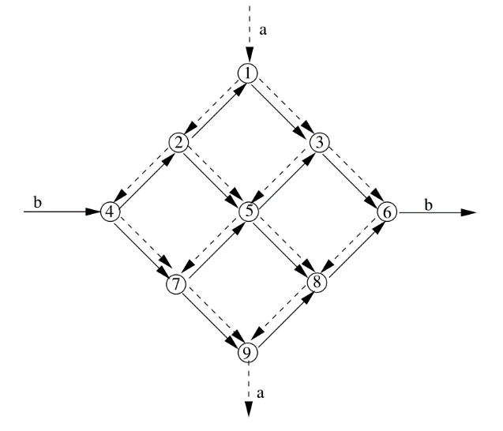

**Problem analysis**

From the property of the network flow problem, we know that the sum of flows at each node should be zero and the flow must be zero or positive so these can be our constraints. Since we have two parallel flows, two different constraint matrices are needed. The network is directed so we shall let the flow in a node be positive and flow outward be negative. To minimize the maximum of the sum of flows, we introduce a new variable to minimize and constraint on this variable is that it is larger than all of the sums.

These analyses can be expressed in the following way: we have two matrices and to represent the red and respective blue links. We call the red respective blue flows on each link as   and . We construct two matrices and so that and represent the sums on each node. So, for each beginning node in and the corresponding element in respective shall be 1 and the ending node shall give -1. Other elements are 0. The matrix multiplying shall result as 0 except the beginning and ending nodes. These values on each node shall be called as respective . Let the variable to be minimized be . Summarize these we shall have the following optimization problem. Here the full independent variable shall have the following shape:

And the optimization problem shall be:

Here we have and so they shall give the following matrices and node values.

These matrices and variables can be rewritten in a more compact way:

With these numbers, we can calculate the optimal solution with .

1. The optimization formulation is shall above.
2. We let and . Then the problem is solved with command . The result is showed below.

|  |
| --- |
| The optimal solution is 1060  The setup is the following:  The red flow from the node 1 to the node 2 is: 954  The red flow from the node 1 to the node 3 is: 954  The red flow from the node 2 to the node 4 is: 424  The red flow from the node 2 to the node 5 is: 530  The red flow from the node 3 to the node 5 is: 530  The red flow from the node 3 to the node 6 is: 424  The red flow from the node 4 to the node 7 is: 424  The red flow from the node 5 to the node 7 is: 530  The red flow from the node 5 to the node 8 is: 530  The red flow from the node 6 to the node 8 is: 424  The red flow from the node 7 to the node 9 is: 954  The red flow from the node 8 to the node 9 is: 954  The blue flow from the node 2 to the node 1 is: 106  The blue flow from the node 1 to the node 3 is: 106  The blue flow from the node 4 to the node 2 is: 636  The blue flow from the node 2 to the node 5 is: 530  The blue flow from the node 5 to the node 3 is: 530  The blue flow from the node 3 to the node 6 is: 636  The blue flow from the node 4 to the node 7 is: 636  The blue flow from the node 7 to the node 5 is: 530  The blue flow from the node 5 to the node 8 is: 530  The blue flow from the node 8 to the node 6 is: 636  The blue flow from the node 7 to the node 9 is: 106  The blue flow from the node 9 to the node 8 is: 106 |

It is showed in the following graph:

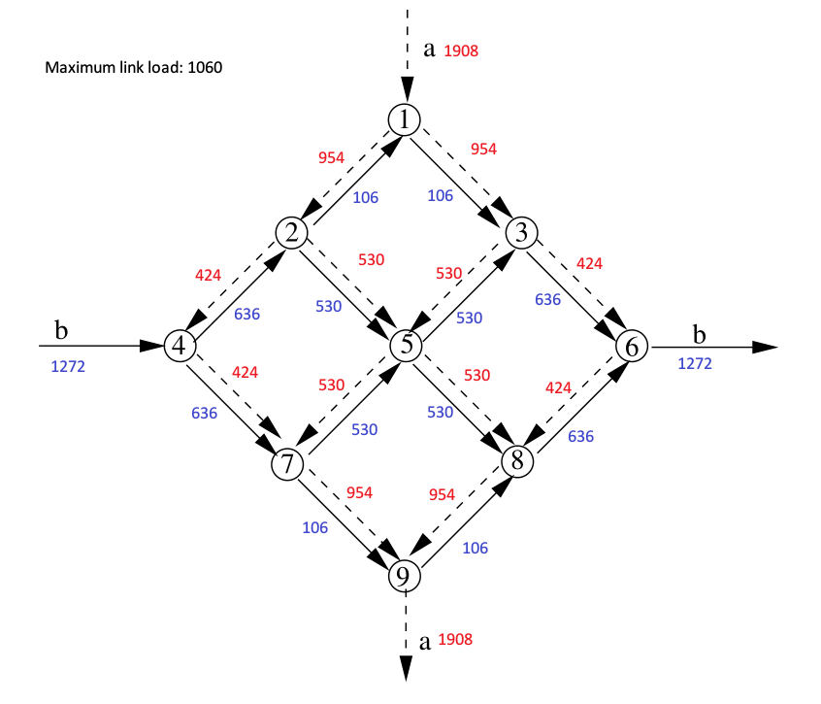

1. Now we change the problem so that there are two blue channels that are not working, i.e. the one from 2 to 1 and the one from 9 to 8. This can be archived by limiting these two links to be less or equal to 0. Then the linear programming problem shall have the following form:

The result is presented below:

|  |
| --- |
| The optimal solution now is 1590  The setup is the following:  The red flow from the node 1 to the node 2 is: 1590  The red flow from the node 1 to the node 3 is: 318  The red flow from the node 2 to the node 4 is: 795  The red flow from the node 2 to the node 5 is: 795  The red flow from the node 3 to the node 5 is: 318  The red flow from the node 3 to the node 6 is: 0  The red flow from the node 4 to the node 7 is: 795  The red flow from the node 5 to the node 7 is: 795  The red flow from the node 5 to the node 8 is: 318  The red flow from the node 6 to the node 8 is: 0  The red flow from the node 7 to the node 9 is: 1590  The red flow from the node 8 to the node 9 is: 318  The blue flow from the node 2 to the node 1 is: 0  The blue flow from the node 1 to the node 3 is: 0  The blue flow from the node 4 to the node 2 is: 795  The blue flow from the node 2 to the node 5 is: 795  The blue flow from the node 5 to the node 3 is: 0  The blue flow from the node 3 to the node 6 is: 0  The blue flow from the node 4 to the node 7 is: 477  The blue flow from the node 7 to the node 5 is: 477  The blue flow from the node 5 to the node 8 is: 1272  The blue flow from the node 8 to the node 6 is: 1272  The blue flow from the node 7 to the node 9 is: 0  The blue flow from the node 9 to the node 8 is: 0 |

The graph is represented as following:

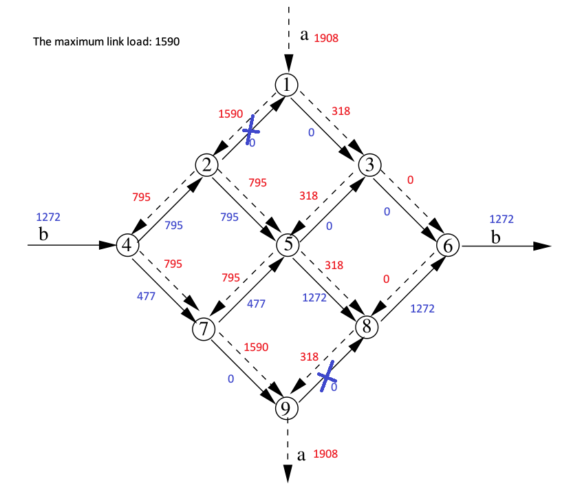

The code to calculate the result:

|  |
| --- |
| %% Initialization  redarc = [ 1 1 2 2 3 3 4 5 5 6 7 8; 2 3 4 5 5 6 7 7 8 8 9 9];  bluearc = [2 1 4 2 5 3 4 7 5 8 7 9; 1 3 2 5 3 6 7 5 8 6 9 8];  lr = size(redarc)*[0 1]';  lb = size(bluearc)*[0 1]';  l = 1+lr+lb;  A = zeros(l, 19);  for i = 1:lr  in = redarc(1, i);  out = redarc(2, i);  A(1+i, 1+in) = 1;  A(1+i, 1+out) = -1;  end  for i = 1:lb  in = bluearc(1, i);  out = bluearc(2, i);  A(1+lr+i, 10+in) = 1;  A(1+lr+i, 10+out) = -1;  end  A = A';  B = zeros(lr, l);  for i = 1:lr  B(i, 1) = -1;  B(i, 1+i) = 1;  B(i, 1+i+lr) = 1;  end  n = zeros(19, 1);  a = 1908;  b = 1272;  n(2) = a;  n(10) = -a;  n(14) = b;  n(16) = -b;  n2 = zeros(lr, 1);  ld = zeros(l, 1);  ub = ones(l, 1)*inf;  ub2 = ones(l, 1)*inf;  ub2(11) = 0;  ub2(19) = 0;  f = zeros(l, 1);  f(1) = 1;    %% 1  format long  s = linprog(f, B, n2, A, n, ld, ub);  fprintf('The optimal solution is %d\n', s(1));  fprintf('The setup is the following: \n')  for i = 1:lr  fprintf('The red flow from the node %d to the node %d is: %d\n', redarc(1, i), redarc(2, i), round(s(1+i)));  end  for i = 1:lr  fprintf('The blue flow from the node %d to the node %d is: %d\n', bluearc(1, i), bluearc(2, i), round(s(1+lr+i)));  end    %% 2  format long  s = linprog(f, B, n2, A, n, ld, ub2);  fprintf('The optimal solution now is %d\n', s(1));  fprintf('The setup is the following: \n')  for i = 1:lr  fprintf('The red flow from the node %d to the node %d is: %d\n', redarc(1, i), redarc(2, i), round(s(1+i)));  end  for i = 1:lr  fprintf('The blue flow from the node %d to the node %d is: %d\n', bluearc(1, i), bluearc(2, i), round(s(1+lr+i)));  end |